Case Study (Hypothetical)
Persistent Oxygen-indUced Tachycardia with Neonatal onsEt (POUTINE), is a life-threatening illness with highest prevalence in Canada and North-Eastern United States, first diagnosed in 1957 in Fernand Lachance of Warick, Quebec. In 2010, a meta-analysis combining the results of three pivotal trials established the efficacy of a surgical treatment for neonates diagnosed with POUTINE was published in JAMA. Authors reported a clinically meaningful but not statistically significant increase in neurodevelopmental impairment at 18-months corrected age

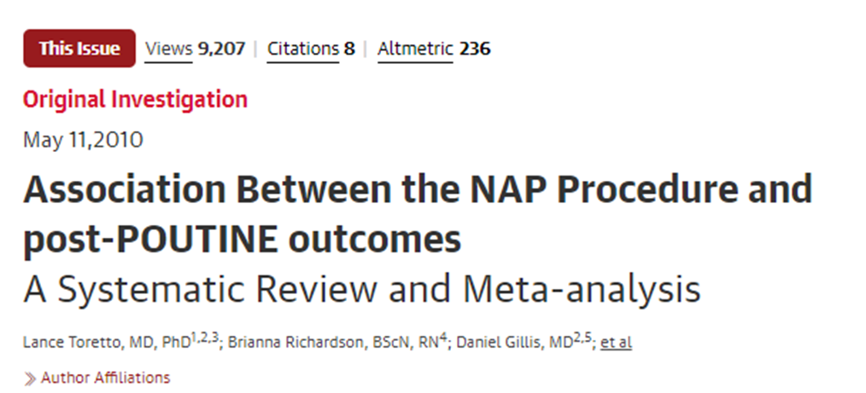

Since 2010 NAP has become standard care in many hospitals. Twn non-randomized studies of varying quality have visited this question since 2010, suggesting conflicting results. All used propensity score matching to derive odds ratios.
- Two matched on all relevant prognostic variables
- Three matched on all most prognostic variables
- Five matched on limited prognostic variables

Your hospital has asked you to provide an updated meta-analysis combining the original RCTs with new randomized studies to assess whether the risk of neurodevelopmental impairment is a concern

Exercise:

You have been provided with an R project that contains a simulated dataset , and script to run various frequentist and Bayesian models. Start by double clicking on the “smdm_obs.Rproj” file, and then navigate to the “01_sim” folder.

** Until you have completed the exercise, please ignore “001_operating_chars.R” and “01_trial_sim.R”

